Latest Round-ups:
Season 2019/20
#9
Midweek Action: It was goals galore on Wednesday evening, with both league and cup action providing some thrilling action. In the Les Phillips Cup, Radstock Town overcame Sherborne in the final Preliminary Round tie, with their 4-2 victory setting up a clash with Street when the competition returns next month. Having taken a seventh minute lead through James Rustell, Radstock saw an own goal and an Ashley Clarke effort turn the game in their hosts favour. With half an hour remaining, Morgan Skipp claimed an equaliser, before Rustell smashed the ball home to put the Miners back ahead. Then, with seven minutes left on the clock, Skipp followed Rustell by completing a double of his own to complete victory. In the Premier Division, a hat-trick from Enis Akgun wasn’t enough for Cadbury Heath who were forced to share the points following an entertaining 3-3 draw with Bridgwater Town. Akgun put the home side ahead on three occasions during the game, but Town found a way back into the game each time, with David O’Hare and Jack Taylor each notching equalisers. The final goal of the game came in stoppage time, with Taylor finding enough space to fire home his second of the night, taking his tally for the season to double figures. 24 hours earlier, Bradford Town returned to winning ways, with a first half header from Matty Morris leading them to a 1-0 triumph away at Odd Down.
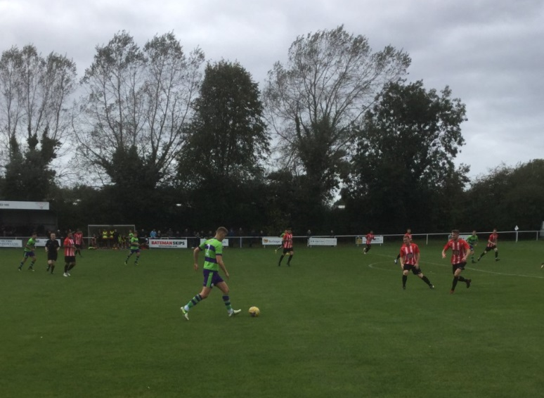
Premier Division: Plymouth Parkway laid down an early season marker, with the league leaders claiming a 5-1 victory away at Bitton. After storming into a sixth minute lead through Billy Palfrey, Parkway had to wait until the early stages of the second half before doubling their lead when Aaron Bentley powered a header into the back of the net. Adam Carter increased the lead to three, but unlike last week, they pushed on in the final 25 minutes, with Palfrey and Jordan Copp adding further goals to complete the big win. Bridgwater Town left it late before seeing off the challenge of Roman Glass St George, with the in-form Jack Taylor leading them to a 2-0 victory. After breaking the deadlock from close range 12 minutes from time, Taylor added a second in stoppage time to bag all three points.
Plymouth Parkway on the attack during their 5-1 win at Bitton, courtesy of John Pool.
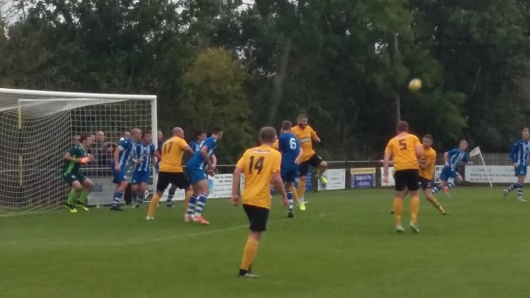
Lowly Bridport claimed an impressive 4-0 win away at Chipping Sodbury Town, less than 24 hours after moving on from their previous management team. It has been a tough start for the Dorset side, but they claimed a second league win of the season thanks to goals from Lewis Clarke, Tom Richardson, Callum Thompson and Max Westlake. Tavistock were another side to win big on their travels, with the Devon side beating Keynsham Town 5-2. An early double from top scorer Jack Crago put Tavistock in command, with Josh Grant extending the lead to three before half-time. Keynsham threatened a fightback during the second half, but further goals from Grant and Liam Prynn led the visitors to victory. Shepton Mallet remain undefeated in the league this season, with Finn Haines and Jack Fillingham both on target during their 4-1 defeat of Brislington in front of a bumper Community Day crowd. Following a four-game winless run in the league, Westbury United stormed back into the top half thanks to a 5-0 thrashing of Wellington. Most of the damage was done early by the Wiltshire outfit, with Sam Jordan scoring a nine-minute hat-trick to put his side three goals to the good inside the opening quarter. Jason Henley completed a perfect first half after netting a penalty, with Ricky Hulbert adding Westbury’s fifth during a quiet second period. Clevedon Town’s promising start to the campaign continued away at Buckland, with Jay Murray scoring the vital goal in their 3-2 win at Homers Heath. The away side catapulted themselves into an early two-goal advantage, with George King providing two clinical finishes inside 15 minutes. Buckland then hit back, with Tom Dunlop’s header halving the deficit, before Dan Western fired home from the penalty spot to draw the sides level. Then, midway through the second half, Murray scored Clevedon’s third of the afternoon to hand them a fifth league win on the spin. Hallen are another team who will be happy with their start to the season, claiming a fourth win in six after beating Street 2-0. Both of Hallen’s goals came in a quick-fire spell midway through the first half, with Isaac Reid putting them ahead at the Tannery Ground, before Kyle Thomas doubled their advantage from the penalty spot. Goals in either half from David Rowe and Jordan Harris led Exmouth to a 2-0 triumph at home to Cadbury Heath, while Jacob Hodgson, Joe White and George Kellow were all on target during Cribbs 3-1 defeat of Odd Down.
Goalmouth action from Clevedon’s 3-2 victory over Buckland Athletic, courtesy of Colin Goodland.
First Division: Wells City produced a stunning display in the early stages of their away game with Corsham Town, eventually strolling to a 7-0 victory. With less than 20 minutes on the clock, Wells had already struck five times against their shell-shocked hosts who have now lost four consecutive home games. Harry Foster was the main beneficiary of Corsham’s struggles, with Wells’ leading scorer completing a hat-trick, with Foster accompanied on the scoresheet by Alex Camm, Ross Padfield and Craig Herrod.
Calne Town will be in possession of top spot when October begins, after Stuart Windsor’s 80th minute strike handed them a hard-fought 1-0 victory away at Bishops Lydeard. In a top-four clash, Cheddar leapfrogged Oldland Abbotonians thanks to a 2-1 victory the Aitchison Playing Field. Oldland have been one of the surprise packages early this season, and they went ahead ten minutes before half-time against the Cheesemen thanks to a powerful finish from John Dempsey. Cheddar weren’t behind for long however, and with one minute left before the break, Dean Griffiths poked home their equaliser from close range. The away side suffered a shock home defeat to Corsham last week, but they rebounded well, claiming all three points at Oldland thanks to George Booth’s late winner. Radstock’s James Rustell bagged a treble during his side’s 4-1 victory over Longwell Green Sports. After Rustell had opened the scoring in the eighth minute, Town’s lead was doubled soon after when Jack Biddiscombe crossed for Morgan Skipp to apply the finishing touches. Longwell Green pulled a goal back two minutes after the break, but their potential fightback hit the rails when they were reduced to ten men for a foul in the box, with Rustell converting the resulting spot kick. Having restored his side’s two-goal advantage, Rustell then completed his hat-trick after being teed up by Josh Howe. Almondsbury made it back-to-back wins in the league thanks to 5-2 victory away at Bishop Sutton. Having taken a 37th minute lead from the spot through Greg Parr, the Almonds doubled their tally soon after when Geraint Williams produced a fine lobbed finish. Ashley Knight then capitalised on an error by the home keeper to grab a third before Bishop Sutton stemmed the tide on the hour mark. Almondsbury played well in the final half-hour and surged to victory thanks two goals in the space of three minutes from Alex Bisp, with Knight producing the assist on each occasion. Portishead’s inconsistent start to the season peaked on Saturday afternoon with a 5-1 win away at Welton Rovers. Liam Villis and Callum Eastwood each struck twice for Portishead, with Alex Chapman also finding the back of the net, killing off any hope Welton had after Rene Adigbo had pulled a goal back for the hosts. Warminster’s impressive away form continued against Sherborne, with a strong team performance landing them a 3-0 victory at Raleigh Grove. James Vincent’s goal had given Warminster a half-time lead, before further efforts from Charlie Walton and George Butler after the interval completed the win. Hengrove’s recent improvements continued at home to Ashton & Backwell United, with an own goal helping them gain a 1-1 draw after they had fallen behind to Harry Walker’s first half opener. Bristol Telephones finally have a point this season after battling with ten men to draw 3-3 against Devizes Town. Following a goalless first half, Rob Mitchell struck within sixty seconds of the restart to put the visitors ahead. The Phones levelled things five minutes later despite seeing a red card, with a penalty from Luke Enderby restoring Devizes’ lead to cap a frantic ten minutes. The home side kept digging in, and after squaring things up for the second time, they looked to have stolen all three points when claiming their first lead in the 90th minute. Devizes managed to just about salvage a point, when second half sub Josh McGrory scrambled home a stoppage time equaliser to save the visitors blushes. At Oaklands Park, Lebeq United produced their best performance of the season so far to topple Wincanton Town by five goals to one.
Western League Statistical Leaders

PREMIER DIVISION LEADING GOAL SCORERS (League only):
Adam Carter (Plymouth Parkway) – 14
Jack Taylor (Bridgwater Town) – 9
Lucas Vowles (Clevedon Town) – 9
Josh Egan (Bitton) – 8
Jack Fillingham (Shepton Mallet) – 8

PREMIER DIVISION TOP ATTENDANCES:
Plymouth Parkway 1 Exmouth Town 0, Wednesday 21st August 2019 - 308
Plymouth Parkway 7 Cadbury Heath 1, Saturday 3rd August 2019 – 303
Bridgwater Town 1 Cribbs 1, Tuesday 6th August 2019 - 237

FIRST DIVISION LEADING GOAL SCORERS (League only):
James Rustell (Radstock Town) – 10
Stuart Windsor (Calne Town) – 9
Adam Wright (Cheddar) – 7
Toby Cole (Wincanton Town) – 6

FIRST DIVISION TOP ATTENDANCES:
Warminster Town 0 Welton Rovers 1, Saturday August 3rd – 174
LEADING SCORERS IN ALL COMPETITIONS:
Jack Crago (Tavistock) - 17
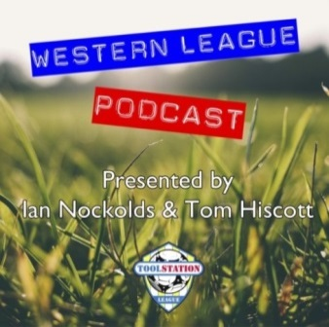
Adam Carter (Plymouth Parkway) – 14
Harry Foster (Wells City) – 12
James Rustell (Radstock Town) – 12
Jack Taylor (Bridgwater Town) - 12
Jack Fillingham (Shepton Mallet) – 11
Stuart Windsor (Calne Town) – 10
Lucas Vowles (Clevedon Town) – 10
Gary Higdon (Bradford Town) – 9
Josh Egan (Bitton) - 8

Be sure to check out the latest podcast, where Ian, Tom & guests recap all the latest news and results from around the Western League. To follow along all season, each broadcast will be available at the following link: http://www.toolstationleague.com/podcasts.php
*All goalscoring stats via
Full-Time FA website

Latest Results
Groundhop Weekend
The beginning of October will see the Toolstation Western League Groundhop Weekend take place, with seven fixtures in the space of 48 hours.
Friday 4th October: Lebeq United vs Radstock Town (19.45)
Saturday 5th October: Portishead Town vs Longwell Green Sports (10.45), Bradford Town vs Clevedon Town (14.00), Devizes Town vs Ashton & Backwell United (16.45) and Warminster Town vs Bristol Telephones (19.45)
Sunday 6th October: Bridport vs Bridgwater Town (10.45) and Wellington vs Exmouth Town (14.30)
Tuesday 24th September 2019
Premier Division
Odd Down 0-1 Bradford Town 108
Wednesday 25th September 2019
Premier Division
Cadbury Heath 3-3 Bridgwater Town 60
Les Phillips Cup – Preliminary Round
Sherborne Town 2-4 Radstock Town 114
Saturday 28th September 2019
Premier Division
Bitton 1-5 Plymouth Parkway 158
Bridgwater Town 2-0 Roman Glass St George 215
Buckland Athletic 2-3 Clevedon Town 112
Chipping Sodbury Town 0-4 Bridport 109
Cribbs 3-1 Odd Down 67
Exmouth Town 2-0 Cadbury Heath 141
Keynsham Town 2-5 Tavistock 126
Shepton Mallet 4-1 Brislington 228
Street 0-2 Hallen 55
Westbury United 5-0 Wellington 61
First Division
Bishop Sutton 2-5 Almondsbury 36
Bishops Lydeard 0-1 Calne Town
Bristol Telephones 3-3 Devizes Town 27
Corsham Town 0-7 Wells City 73
Hengrove Athletic 1-1 Ashton & Backwell United 73
Lebeq United 5-1 Wincanton Town
Oldland Abbotonians 1-2 Cheddar 52
Radstock Town 4-1 Longwell Green Sports 48
Sherborne Town 0-3 Warminster Town 80
Welton Rovers 1-5 Portishead Town 77

Upcoming Fixtures
Tuesday 1st October 2019
Premier Division
Bitton vs Brislington 19:30KO
Odd Down vs Chipping Sodbury Town 19:45KO
Shepton Mallet vs Bradford Town 19:30KO
First Division
Devizes Town vs Welton Rovers 19:30KO
Wednesday 2nd October 2019
Premier Division
Cadbury Heath vs Hallen 19:30KO
Clevedon Town vs Street 19:45KO
Roman Glass St George vs Westbury United 19:30KO
Wellington vs Tavistock 19:45KO
Friday 4th October 2019
First Division
Lebeq United vs Radstock Town 19:45KO
Saturday 5th October 2019 (KICK OFF AT 3.00PM UNLESS NOTED)
Premier Division
Bradford Town vs Clevedon Town 14:00KO
Brislington vs Chipping Sodbury Town
Cadbury Heath vs Street
Cribbs vs Buckland Athletic
Hallen vs Plymouth Parkway
Roman Glass St George vs Shepton Mallet
Tavistock vs Odd Down
Westbury United vs Bitton
First Division
Almondsbury vs Sherborne Town
Calne Town vs Oldland Abbotonians
Cheddar vs Hengrove Athletic
Corsham Town vs Welton Rovers
Devizes Town vs Ashton & Backwell United 16:45KO
Portishead Town vs Longwell Green Sports 10:45KO
Warminster Town vs Bristol Telephones 19:45KO
Wells City vs Bishops Lydeard
Wincanton Town vs Bishop Sutton
Sunday 6th October 2019
Premier Division
Bridport vs Bridgwater Town 10:45KO
Wellington vs Exmouth Town 14:00KO

League Tables
Premier Division
 |  | P | W | D | L | F | A | GD | PTS
1 | Plymouth Parkway | 8 | 6 | 1 | 1 | 34 | 7 | 27 | 19
2 | Bridgwater Town | 8 | 5 | 2 | 1 | 26 | 11 | 15 | 17
3 | Clevedon Town | 7 | 5 | 1 | 1 | 20 | 13 | 7 | 16
4 | Bradford Town | 6 | 5 | 0 | 1 | 17 | 9 | 8 | 15
5 | Shepton Mallet | 5 | 4 | 1 | 0 | 17 | 7 | 10 | 13
6 | Bitton | 6 | 4 | 0 | 2 | 22 | 9 | 13 | 12
7 | Exmouth Town | 5 | 4 | 0 | 1 | 11 | 2 | 9 | 12
8 | Hallen | 6 | 4 | 0 | 2 | 14 | 13 | 1 | 12
9 | Brislington | 8 | 4 | 0 | 4 | 13 | 20 | -7 | 12
10 | Westbury United | 7 | 3 | 1 | 3 | 16 | 14 | 2 | 10
11 | Odd Down | 10 | 3 | 1 | 6 | 13 | 24 | -11 | 10
12 | Tavistock | 4 | 3 | 0 | 1 | 14 | 7 | 7 | 9
13 | Street | 6 | 3 | 0 | 3 | 11 | 13 | -2 | 9
14 | Buckland Athletic | 7 | 3 | 0 | 4 | 12 | 16 | -4 | 9
15 | Keynsham Town | 8 | 2 | 2 | 4 | 18 | 22 | -4 | 8
16 | Cadbury Heath | 8 | 2 | 2 | 4 | 11 | 19 | -8 | 8
17 | Bridport | 9 | 2 | 1 | 6 | 16 | 26 | -10 | 7
18 | Cribbs | 8 | 2 | 1 | 5 | 8 | 19 | -11 | 7
19 | Chipping Sodbury Town | 9 | 1 | 1 | 7 | 7 | 31 | -24 | 4
20 | Roman Glass St George | 5 | 1 | 0 | 4 | 11 | 8 | 3 | 3
21 | Wellington | 8 | 1 | 0 | 7 | 6 | 27 | -21 | 3

First Division
 |  | P | W | D | L | F | A | GD | PTS
1 | Calne Town | 8 | 5 | 1 | 2 | 14 | 5 | 9 | 16
2 | Wells City | 7 | 5 | 0 | 2 | 21 | 11 | 10 | 15
3 | Cheddar | 6 | 5 | 0 | 1 | 16 | 9 | 7 | 15
4 | Oldland Abbotonians | 9 | 4 | 3 | 2 | 9 | 9 | 0 | 15
5 | Wincanton Town | 7 | 4 | 2 | 1 | 18 | 12 | 6 | 14
6 | Portishead Town | 7 | 4 | 0 | 3 | 19 | 13 | 6 | 12
7 | Radstock Town | 7 | 4 | 0 | 3 | 19 | 14 | 5 | 12
8 | Ashton & Backwell United | 7 | 3 | 3 | 1 | 10 | 8 | 2 | 12
9 | Sherborne Town | 7 | 4 | 0 | 3 | 13 | 14 | -1 | 12
10 | Almondsbury | 7 | 3 | 1 | 3 | 12 | 10 | 2 | 10
11 | Longwell Green Sports | 7 | 3 | 1 | 3 | 12 | 12 | 0 | 10
12 | Bishops Lydeard | 7 | 3 | 0 | 4 | 15 | 11 | 4 | 9
13 | Warminster Town | 7 | 3 | 0 | 4 | 15 | 11 | 4 | 9
14 | Lebeq United | 7 | 3 | 0 | 4 | 14 | 17 | -3 | 9
15 | Corsham Town | 8 | 3 | 0 | 5 | 13 | 27 | -14 | 9
16 | Devizes Town | 6 | 2 | 1 | 3 | 16 | 15 | 1 | 7
17 | Bishop Sutton | 7 | 2 | 0 | 5 | 11 | 15 | -4 | 6
18 | Welton Rovers | 6 | 2 | 0 | 4 | 6 | 13 | -7 | 6
19 | Hengrove Athletic | 8 | 1 | 3 | 4 | 5 | 23 | -18 | 6
20 | Bristol Telephones | 7 | 0 | 1 | 6 | 9 | 18 | -9 | 1

